CHAPTER 9
Consumer Choice and Behavioral Economics
- Chapter Summary
- Learning Objectives
- Chapter Outline
Teaching Tips/Topics for Discussion
- Solved Problems
- Solutions to Review Questions and Problems and Applications
1. Chapter Summary
Economists assume that consumers act in a rational way when they make decisions. They spend their income to maximize utility. The marginal utility a person receives from consuming an additional unit of a good or service will diminish as more is consumed in a given period of time. Consumers maximize their utility when the marginal utility per dollar for each good or service consumed is equal.
The law of demand states that demand curves slope downward. This is true because of the income and substitution effects from a change in price. For normal goods, the income and substitution effects both lead consumers to buy more of a good after its price falls. For inferior goods, the income effect from a price decrease causes a decrease in quantity demanded, whereas the substitution effect causes quantity demanded to increase. Although it is possible for the income effect to be greater than the substitution effect for an inferior good – Giffen goods have this characteristic – the substitution effect is typically greater.
Social factors affect consumer choices. Celebrity endorsements have long been used by firms to induce consumers to buy their products because some consumers want to buy what others have bought. There are network externalities in the consumption of a product if the usefulness of the product increases with the number of people who use it. Network externalities may result in consumers buying products that contain inferior technologies if they create significant switching costs. Once a product becomes established, consumers may find it too costly to switch to a new product with better technology.
Though consumer choice theory assumes consumers try to make themselves as well off as possible, people like to be treated fairly and try to treat others fairly even if this makes them worse off financially. Examples of this behavior are voluntary tipping in restaurants and donating to charities. Economists have used laboratory experiments to increase their understanding of the role fairness plays in consumer decision making. In these experiments, consumers usually choose outcomes that make themselves worse off financially but are perceived as fair.
A new area of economics, behavioral economics, studies decisions that do not appear to be rational. The mistakes consumers make include: (1) They ignore the nonmonetary opportunity costs of choices. (2) They fail to ignore sunk costs. (3) They are overly optimistic about their future behavior.

2. Learning Objectives
Students should be able to:
- Define utility and explain how consumers choose goods and services to maximize their utility.
- Use the concept of utility to explain how the law of demand results from consumers adjusting their consumption choices to changes in prices.
- Explain how social influences can affect consumption choices.
- Describe how people can improve their decision making by taking into account nonmonetary opportunity costs, ignoring sunk costs, and being more realistic about their future behavior.

3. Chapter Outline
Can LeBron James Get You to Drink Powerade?
1. Firms often hire celebrities to endorse their products with the expectation that the endorsements will increase their sales. For example, for nearly 100 years Coca-Cola has used movie stars and other celebrities in their advertising.
►Teaching tips: Advertising is an ideal subject for classroom discussion since students are familiar with celebrities who appear in print and broadcast ads. An Inside Look at the end of this chapter describes some of the pitfalls of using celebrities to pitch firms’ products. The questions at the end of An Inside Look can be used as the starting point for discussion. Some students will claim that advertising only increases the costs of marketing products which are passed on to consumers in higher prices. But another attribute of advertising is it provides information to consumers. Ads placed in newspapers and magazines, in particular, provide valuable information including dates and locations of special sales. Information is a valuable, though intangible, product for consumers. Often, costs must be incurred to obtain useful information.

Utility and Consumer Decision Making
1. Utility is the enjoyment or satisfaction people receive from consuming goods and services.
Economists assume consumers spend their limited budgets to derive the most utility.
- If one assumes utility can somehow be measured, then a certain number of “utils” (units of utility or satisfaction) are associated with each unit of a product.
- Marginal utility (MU) is the change in total utility a person receives from consuming one additional unit of a good or service.
- The law of diminishing marginal utility states that consumers experience diminishing additional satisfaction as they consume more of a good or service during a given period of time.
►Teaching tips: The assumption that utility can literally be measured, as if a mechanism strapped to a consumer would register “10 utils” on a digital display after eating a hamburger, is of course nonsensical. But it is realistic to assume a consumer prefers a certain amount of one product to an amount of another or that she is indifferent between consuming two different products. Economists do not believe in “cardinal utility” – utility measured in utils. They do believe in “ordinal utility” – that consumers can rank products, or combinations of products, based on preferences. Cardinal and ordinal measurements can be found on newspapers’ sports pages. A list of baseball teams’ won-loss records from first to last is an ordinal ranking. Baseball standings also include the number of games teams are behind the first place club. This is a cardinal ranking since it provides information regarding how far from first place each team is.
2. Since consumers have limited income (a budget constraint), they try to receive the most utility they can as they spend it.
- A budget constraint is the limited amount of income available to consumers to spend on goods and services.
- The model of consumer behavior can be used to determine the optimal amounts of goods and services a consumer will purchase given: (a) a knowledge of the marginal utilities (MU) of the goods and services (b) the prices of the goods and services and (c) the consumer’s budget constraint.
- This model applies a key economic principle: optimal decisions are made at the margin.
3. The following information is taken from Table 9-2. It is assumed that the price of pizza is $2 per slice and the price of a cup of Coke is $1. A consumer is assumed to have $10 to spend on pizza and Coke.
# of slices MU per # of cups of MU
of pizza dollar (pizza) Coke per dollar (Coke)
1 10 1 20
2 8 2 15
3 5 3 10
4 3 4 5
5 1 5 3

- The consumer maximizes utility by first buying the good for which the MU per dollar is higher.
- Since the first cup of Coke has a higher MU per dollar (20) than the MU per dollar from the first slice of pizza (10), the consumer will first spend $1 on a cup of Coke.
- Because of the law of diminishing marginal utility, the MU of Coke and pizza decline as more of each is consumed.
- The consumer will compare the MU per dollar of the next unit of each good in deciding how to spend his income.
- The consumer will maximize his/her utility when: (a) MU/Price is equal for each good consumed and (b) total spending on all goods equals the income available.
►Teaching tips: Students have difficulty understanding the utility-maximizing rule: consumers will equate the MU per dollar for all goods and services they consume. Ask them to imagine a consumer in a store with a shopping cart with all of the items she wishes to purchase. Because the consumer has not yet bought the items, it is possible to have a “utility inspector” with a magical ability to know the MU of each item in the cart and who will suggest ways to make the consumer better off. Assume that the MU per dollar for two items is unequal and the price of each item is the same (for example, $1). Also assume there is more than one can of peas (MU per dollar = 20) and more than one can of corn (MU per dollar = 10) in the cart. The inspector can make the consumer better off by taking away one can of corn and replacing it with one more can of peas. The total value of the goods in the cart has not changed, but there is a net gain of 10 utils (20 minus 10). As similar exchanges are made, the MU of corn will become more than 10 – this represents the last can placed in the cart – and the MU of peas will be less since there is now one more can of peas in the cart.
4. The rule of equal marginal utility per dollar can be used to analyze consumer response to a price change. Using the previous example, if the price of pizza were to fall to $1.50, there would be a substitution and income effect on the quantity of pizza demanded.
# of slices MU per # of cups of MU
of pizza dollar (pizza) Coke per dollar (Coke)
1 13.3 1 20
2 10.7 2 15
3 6.7 3 10
4 4 4 5
5 1.3 5 3

- The decrease in price has raised the MU per dollar of pizza. Previously, the consumer’s $10 budget was used to buy 3 slices of pizza and 4 cups of Coke.
- At the lower price of pizza, the same combination of goods costs only $8.50. This increase in purchasing power is the income effect of the price change.
- The income effect is the change in the quantity demanded of a good that results from the effect of a change in price on consumer purchasing power, holding all other factors constant.
- If pizza is a normal good, the income effect increases the quantity demanded of pizza.
- If pizza is an inferior good, the income effect decreases the quantity demanded of pizza.
- The substitution effect is the change in quantity demanded of a good that results from a change in price, making the good more or less expensive relative to other goods, holding constant the effect of the price change on consumer purchasing power.
Where Demand Curves Come From
1. The substitution and income effects of price changes explain why demand curves for normal goods are downward sloping.
2. Although the substitution and income effects of price changes for inferior goods have opposite effects on quantity demanded, the income effect is typically quite small. Therefore, the demand curves for inferior goods obey the law of demand.
►Teaching tips: The textbook makes a brief reference to Giffen goods – goods that have upward sloping demand curves. A Giffen good is an inferior good on which consumers spend a large fraction of their incomes. Giffen goods are so rare that most references to them use the same possible example: potatoes in Ireland in the mid-1800s. This example is plausible because potatoes were an important part of the typical Irish household’s budget during this time period. The price of potatoes rose sharply during the famous potato famine that began in the 1840s, when the crop was infected with a mysterious blight. As the price of potatoes rose, some economists have argued, many Irish families had to sacrifice income spent on other goods to support their consumption of potatoes; in other words, the demand curve for potatoes was upward sloping. However, since the supply of potatoes had fallen, and there is evidence that Ireland did not import enough potatoes to make up for their domestic crop losses, Irish families could not buy more than they had in the past. Even this special case does not provide an example of a Giffen good.
Social Influences on Decision Making
1. Consumer decisions appear to be influenced by the actions and perceptions of other consumers.
- Some people obtain utility from consuming goods that others consume.
- Firms use celebrity endorsements and other strategies to sell products on the basis of consumers’ desires to be similar in some ways to celebrities and others with whom they want to associate.
- Endorsements can be effective when consumers believe celebrities are knowledgeable about the products they endorse.
2. Consumer decisions can be affected by network externalities.
- The utility of some products increases as more consumers use them.
- Consumers’ willingness to buy new technologies, such as DVDs, is enhanced when they know many others have bought them, since this will ensure these technologies will be available in the future.
►Teaching tips: Prior to the 1970s, owners of foreign-made automobiles often had difficulty locating parts for their cars and mechanics who could repair them. One would usually need hard-to-find metric wrenches to do even simple repair work. The rapid increase in oil and gasoline prices beginning in 1973 caused a surge in demand for the smaller, more fuel-efficient automobiles offered by Japanese and German automakers. By the late 20th century, foreign manufacturers had gained significant market share in the United States. The availability of parts or mechanics was no longer an issue for buyers of domestic or foreign automobiles.
3. Recent studies of consumer behavior indicate consumers value the perception of fairness when they make decisions.
- Awareness of consumer concerns for fairness affects firms’ decisions.
- Tickets for Broadway plays, concerts and sporting contests are often priced below their equilibrium levels. These decisions appear to be a response to consumers’ concerns that the equilibrium prices are unfairly high.
►Teaching tips: Consumers’ concern for fairness explains the social stigma attached to the practice of “ticket scalping.” In some cities, the practice is illegal despite the voluntary nature of the transactions. Scalpers typically buy tickets for events well before the events take place. They sell tickets at a premium if the demand for the event increases but suffer losses if the demand falls due to inclement weather, or when a baseball or basketball game has no playoff implications for the teams involved. Most economists see the actions of scalpers as benign or beneficial for consumers. However, many other people disagree and perceive scalping as an unfair practice.

Behavioral Economics: Do People Make Their Choices Rationally?
1. Some economists have questioned whether consumers make decisions rationally. Consumers sometimes make poor choices. Among the most important reasons for poor choices are:
- Failure to account for nonmonetary opportunity costs.
- Failure to ignore sunk costs.
- Overly optimistic assessments of future behavior.
►Teaching tips: Sunk costs are often not ignored not only by consumers but by government officials and even baseball executives. Ask students to read the following and explain how the importance of sunk costs is demonstrated:

Before the 2002 baseball season, Allard Baird, general manager of the Kansas City Royals, decided to release pitcher José Rosado. Writing about this decision, Rany Jazayerli wrote: “[I]t’s the first piece of evidence…that Baird understands…sunk costs. Rosado was paid $3.5 million to make five starts in 2000…$3.25 million again in 2001 to do absolutely nothing. He’s already guaranteed $533,000 this year…it must be awfully tempting to keep him on the roster…in hope that, after so much time and so much money, their investment might finally pay some dividends…Baird cut Rosado because he compared Rosado to the other [pitching] options…and came to the…conclusion that the only thing Rosado had on [other pitchers] is service time and income.”
Source: Rany Jazayerdi, “Rany on the Royals: Cutting Bait,” posted on baseballprospectus.com, March 12, 2002.

4. Solved Problems
Chapter 9 in the textbook includes two Solved Problems to support Learning Objectives 1 (Define utility and explain how consumers choose goods and services to maximize their utility) and 4 (Describe how people can improve their decision making by taking into account nonmonetary opportunity costs, ignoring sunk costs, and being more realistic about their future behavior). The following Solved Problems support this chapter’s two other learning objectives.

Solved Problem 9-3 Supports Learning Objective 2: Use the concept of utility to explain how the law of demand results from consumers adjusting their consumption choices to changes in prices.

Of Jake, Wings and Dogs
The rule of equal marginal utility per dollar (MU/P) can be used to analyze how consumers adjust their buying decisions in response to price changes. The following table shows Jake’s utility from his two favorite foods: chicken wings (each order contains 10 wings) and chili dogs.

Chicken Wings Chili Dogs
MU per MU per
Orders order Chili dogs Chili Dog
1 120 1 80
2 80 2 64
3 40 3 40
4 20 4 20
5 8 5 8

Assume that Jake has $20. Assume also that the price of chicken wings is $4 per order and that the price of chili dogs is initially $2. The following table shows the MU/P for wings and chili dogs at their initial prices, as well as the MU/P of chili dogs after the price increases to $4.

MU/P MU/P MU/P
Orders (price = $4) Chili Dogs (price = $2) (price = $4)
1 30 1 40 20
2 20 2 32 16
3 10 3 20 10
4 5 4 10 5
5 2 5 4 2

- Using the rule of equal marginal utility per dollar, how many orders of wings and chili dogs will Jake consume when the price of chili dogs is $2?
- How many wings and chili dogs will Jake consume when the price of chili dogs is $4?
- What is the substitution effect of the change in the price of chili dogs? What is the income effect?
- How does Jake’s response to the increase in the price of chili dogs illustrate the law of demand?

Solving the Problem:
Step 1: Review the chapter material. This problem involves using the concept of utility to describe the law of demand. You may want to review the section The Income Effect and Substitution Effect of a Price Change, which begins on page 280 in the textbook.
Step 2: Answer question (a). Jake will first consume two chili dogs since the MU/P of the first and second chili dog is greater than the MU/P of the first order of wings. Jake will then consume one order of wings. Since the MU/P for the second order of wings and a third chili dog are equal (20), Jake will consume one more of each. At this point Jake will have spent $14. With his remaining $6 he will consume a third order of wings and a fourth chili dog. Jake will now have spent his $20 and the MU/P of both goods will be equal (10).
Step 3: Answer question (b). After the price of chili dogs rises, the MU/P for this good falls. Jake will spend $16 on 2 chili dogs (2 x $4 = $8) and two orders of wings (2 x $4 = $8). Since the MU/P (10) for the third chili dog and third order of wings is the same, Jake will be indifferent between these two choices. Assume that he buys a third chili dog.
Step 4: Answer question (c). When the MU/P for chili dogs falls because of the price increase, the opportunity cost of consuming each chili dog rises. As a result, Jake will substitute towards wings, holding constant the effect on his purchasing power. This is the substitution effect. After the price increase, it would require $28 for Jake to buy the same number of chicken wings (3 x $4 = $12) and chili dogs (4 x $4 = $16) as he bought before the price increase. Since his purchasing power, or real income, has declined, he will buy fewer chili dogs because of the income effect if chili dogs are a normal good. He would buy more chili dogs because of the income effect if chili dogs are inferior goods; this would require Jake to buy fewer wings. Since the income effect is small, the net effect of the price increase is to decrease the quantity demanded of chili dogs.
Step 5: Answer question (d). The change in the price caused a reduction in the quantity demanded of chili dogs. According to the law of the demand, as the price of a product increases, the quantity demanded will decrease. Jake’s response to the price increase for chili dogs is consistent with this law.

Price Quantity Demanded
of Chili Dogs
$4 3
$2 4

Solved Problem 9-4 Supports Learning Objective 3: Explain how social influences can affect consumption choices.

“Ladies and gentlemen: In this corner, the undisputed heavyweight champion of the marketing world: George Foreman!”
After stunning losses to Muhammad Ali and Jimmy Young, former heavyweight boxing champion George Foreman retired from the ring and spent over a decade in near obscurity. At age 40 he began an improbable comeback that resulted in his regaining the heavyweight title in 1994 at age 45. But even more improbable has been Foreman’s emergence as one of the most successful celebrity endorsers of any era. Salton Inc., the manufacturer of The George Foreman Grill, has sold more than 55 million grills since the product was first launched in 1995. Foreman has endorsed other products as well, including Meineke Mufflers and the George Foreman Signature Collection, a clothing line sold by the Casual Male Big and Tall retail chain. By the end of 2004, Foreman had earned about $240 million from celebrity endorsements, nearly three times what he earned from boxing. An important part of Foreman’s success is his amiable persona, a contrast with the sullen image he had in his early boxing years. Foreman recognizes the importance of his positive image.
He tries all potential new products – gathering approvals from his wife and children – before putting his name on anything. John Bellamy, CEO of Knockout Group Inc., says Foreman went so far as to put an ethics clause in Knockout’s contract prohibiting it from selling the company to anyone involved in alcohol, tobacco, pornography, or gambling…“The most important thing to him is image,” Bellamy says.
Source: “George Foreman: Marketing Champ of the World,” BusinessWeek Online. December 20, 2004.

- Why do consumers buy products endorsed by George Foreman?
- Chapter 9 refers to some celebrity endorsers, for example Whoopi Goldberg and Mary-Kate Olsen, who were dropped from product endorsements. Contrast Foreman’s success with these marketing failures.

Solving the Problem:
Step 1: Review the chapter material. This problem describes an example of the use of celebrity endorsements by businesses to influence the choices consumers make, so you may want to review the section Social Influences on Decision Making, which begins on page 282 of the textbook.
Step 2: Answer question (a): Part of Foreman’s appeal stems from his personality. Many consumers know and like Foreman and want to own products he endorses because they know other people who own these products. Consumers may also believe Foreman is knowledgeable about the products he endorses, such as George Foreman’s Grills and his line of “Big and Tall” men’s clothing.
Step 3: Answer question (b): Goldberg and Olsen received adverse publicity for behavior that made companies unwilling to continue using them in their advertising campaigns. In contrast, Foreman carefully selects the products he endorses to maintain his credibility with consumers and the products he endorses.

CHAPTER 9 Appendix
Using Indifference Curves and Budget Lines
to Understand Consumer Behavior

Consumer Preferences
1. Rather than assuming utility is measured in utils, it is more realistic to assume that consumers rank different combinations of goods and services in terms of how much utility they provide.
- If a consumer is presented with two alternative consumption bundles (A and B), one can assume the consumer will be able to decide on one of the following.
  - The consumer prefers A to B.
  - The consumer prefers B to A.
  - The consumer is indifferent between A and B; she receives equal utility from A and B.
- Assume the consumer’s preferences are transitive.
  - If she prefers A to B and B to C,
  - Then she must prefer A to C.
2. Given the assumptions made, one can draw a map of a consumer’s preferences using indifference curves.
- An indifference curve is a curve that shows the combinations of consumption bundles that give the consumer the same utility.
- An indifference curve assumes that consumption bundles consist of various amounts of only two goods.
- Each possible combination of two goods (for example, cans of Coca-Cola and slices of pizza) has an indifference curve passing through it.
- A consumer is indifferent about all the consumption bundles that are on the same indifference curve.
- In a graph of indifference curves, the further to the right a curve is, the greater the utility it represents.
- Along an indifference curve, the slope indicates the rate at which a consumer is willing to trade off one product for another, keeping total utility constant.
- The marginal rate of substitution (MRS) is the slope of an indifference curve; it represents the rate at which a consumer would be willing to trade off one good for another.
- The MRS is downward-sloping and becomes less steep as one moves down the curve; that is, indifference curves are bowed in or convex.

3. Indifference curves do not cross.
- If two indifference curves (I₁ and I₂) crossed, they would share a common point (point X).
- Assume that Y is a point on I₂ so that the consumer would be indifferent between points X and Y.
- Assume that point Y lies on the portion of I₂ that is above I₁.
- Z is another point on I₁ so that the consumer is indifferent between X and Z.
- Because of the transitivity assumption, the consumer should be indifferent between points Z and Y, but Y represents more of both Coke and pizza.
- The violation of the transitivity assumption provides that indifference curves cannot cross.
►Teaching tips: Instructors should not cover indifference curves unless students have a superior background in mathematics. Even these students are likely to require considerable effort to understand this topic. Be sure students understand Figures 9A-1 and 9A-2 and the description of these graphs in the text. Notice that the indifference curves do not bend backward, or become positively sloped. This means that receiving more of Coke and pizza always increases utility. Ask students what the implication would be if the curves in 9A-1 began to bend backward. This would mean that receiving more of one good (for example, pizza) would lower the consumer’s utility and require more of the other good to maintain total utility at the same level.

The Budget Constraint
1. A consumer’s budget constraint is the amount of income she has to spend on goods and services.
- Knowing a consumer’s income and the prices of two goods she can buy allows one to draw a budget line in a graph with the amount of either good measured on the vertical axis and horizontal axis of the graph.
- The vertical intercept of the budget line is the maximum amount of a good (for example, cans of Coke) that can be bought with the consumer’s income (for example, $10) and the price of the good (for example, $1).
- The horizontal axis of the budget line is the maximum amount of the other good (for example, slices of pizza) that can be bought with the consumer’s income and the price of the good (for example, $2).
- The slope of the budget constraint is constant and is equal to the ratio of price of pizza (the good measured on the horizontal axis) to the price of Coke (the good measured along the vertical axis) multiplied by negative 1.
►Teaching tips: Budget lines should be easier for students to understand than indifference curves because the lines are linear and have constant slopes. Also, budget lines are similar to the production possibilities frontiers introduced in chapter 2. Figure 9A-3 illustrates a budget line for Dave, a representative consumer. Points on the budget line represent maximum alternative combinations of two goods; points inside the budget line represent affordable consumption bundles and points above the budget line represent unaffordable consumption bundles. One can refer to the budget line as a “consumption possibilities frontier” to reinforce its similarities with a production possibilities frontier.

Choosing the Optimal Consumption of Pizza and Coke
1. To maximize utility, a consumer needs to be on the highest indifference curve, given her budget constraint.
- The combination of goods that will maximize utility subject to a consumer’s budget constraint is at the tangency of the budget line with an indifference curve.
2. If the price of one of the goods changes (for example, if the price of pizza decreases to $1) the budget line will change.
- When the price of pizza decreases to $1, more consumption bundles can be purchased.
- The change in the budget line from a price decrease results in a new combination of goods that will maximize utility.
- The consumer can reach a higher indifference curve.
3. By changing the price of one of the goods and determining the amount of the good that will be purchased after the price change, one can derive a demand curve.
4. Indifference curves and budget constraints can be used to analyze the income and substitution effects from a price change.
- Assume that a consumer is maximizing utility at the tangency of a budget line and indifference curve I₁.
- Assume a change in the price of pizza from $2 to $1.
- The budget line changes to reflect the price change and the lines’ new slope.
- The consumer maximizes utility at the tangency of the new budget line and indifference curve I₂.
- Drawing a line parallel to the new budget line (that is, with the new line’s slope) tangent to the I₁ illustrates the substitution effect of the price change.
- The change in consumption from the tangency of the line parallel to the new budget line and I₁ to the tangency of the new budget line and I₂ illustrates the income effect of the change in price.
5. Increases in income shift the budget line outward and enable consumers to reach higher indifference curves.
►Teaching tips: It is much easier to understand how the optimal combination of goods is determined and how price changes change the optimal combination with graphs than with words alone. Be sure students understand the graphs in Figures 9A-4 through 9A-8. Making the Connection 9A-1 and Solved Problem 9A-1 should be assigned as homework.
The Slope of the Indifference Curve, the Slope of the Budget Line, and the Rule of Equal Marginal Utility per Dollar
1. At the point of optimal consumption, the MRS is equal to the ratio of the price of the product on the horizontal axis to the price of the product on the vertical axis.
- The slope of the indifference curve is the rate at which a consumer is willing to trade off one good for the other.
- The slope of the budget line is the rate at which a consumer is able to trade off one good for the other.
- Only at the point of optimal consumption is the rate at which a consumer is willing to trade off one good for the other equal to the rate at which she can trade off one good for the other.
2. Indifference curves and budget lines can be used to explain the rule of equal marginal utility per dollar.
- When a consumer moves downward along an indifference curve, more of one good (for example, pizza) and less of another good (for example, Coke) is consumed but utility is constant.
- Moving along an indifference curve results in:
  - A loss in utility equal to the change in the quantity of Coke multiplied by the marginal utility of Coke (= - Δ Coke x MU_{Coke}).
  - A gain in utility equal to the change in the quantity of pizza multiplied by the marginal utility of pizza (= + Δ pizza x MU_{pizza}).
- The loss in utility from consuming less Coke equals the gain in utility from consuming more pizza because the consumer remains on the same indifference curve.
- The change in utility can be written:
  - - Δ Coke x MU_{Coke} = + Δ pizza x MU_{pizza}
  - This can be rewritten:
  - - Δ Coke = MU_{pizza}
Δ pizza MU_{Coke}
  - MRS = MU_{pizza}
MU_{Coke}
  - Since the slope of the indifference curve (MRS) equals the slope of the budget line at the point of optimal consumption, then:
  - MU_{pizza} = P _{pizza}
MU_{Coke} P _{Coke}
  - Rewriting this equation yields marginal utility per dollar:
  - MU_{pizza} = MU_{Coke}
P _{pizza} P _{Coke}
►Teaching tips: It is not critical for students to understand the derivation of the rule of equal marginal utility per dollar, but if you assign this topic or discuss it in class, consider substituting simple values for changes in quantities and marginal utilities. Students will find it easier to understand the derivation with numbers rather than just words.
5. Solutions to Review Questions and Problems and Applications

Answers to Thinking Critically Questions

1. Management will probably do more “hand-wringing” and “teeth-gnashing” when they have to put more money into an ad campaign, but the money they have already poured into the campaign is a sunk cost, so they should ignore it in deciding whether or not to cancel the campaign.

2. If you think that celebrity endorsements provide useful information to consumers, then you’ll disagree with those that say such endorsements serve no useful social purpose. Even if you think they serve little or no useful social purpose, merely luring customers from one product to another for no good reason, you might still be against banning them because even this type of advertisement can promote competition among firms, which benefits consumers. However, if you think they simply represent a waste of resources, you may be in favor of banning them.

Answers to Review Questions

1. Utility is the enjoyment or satisfaction that people receive from consuming goods and services. It is not possible to measure utility or to compare it across people.

2. Marginal utility is the extra utility a person receives from consuming one additional unit of a good or service. The law of diminishing marginal utility says that consumers will experience reductions in additional satisfaction as they consume more of a good or service during a given period of time. Marginal utility is more useful in consumer decision making because consumption decisions are usually made on the margin, involving the decision of whether to consume a little bit more or a little bit less of a product.

3. The budget constraint is the limited amount of income available for a consumer to spend on goods and services. The rule of equal marginal utility per dollar says that a consumer will make the optimal decision by allocating his or her budget so that the marginal utility per dollar spent is the same for all goods being consumed.

4. When the price of a good falls, a consumer will adjust his or her purchases because the marginal utility per dollar spent will no longer be the same for all goods. The lower price will lead to a substitution effect and an income effect, both of which will usually cause the quantity demanded of the good to rise. The income effect is the change in the quantity demanded of a good that results from the effect of a change in the price on the consumer’s purchasing power, holding all other factors constant. When price falls, the consumer’s purchasing power rises and he or she will want to buy more of all normal goods. The substitution effect is the change in the quantity demanded of a good that results from a change in price, making the good more or less expensive relative to other goods, holding constant the effect of the price change on the consumer’s purchasing power. When price falls, the good becomes less expensive relative to other goods, so the consumer will want to buy more of it.

5. Social influences will probably be greater in choosing a restaurant, because this choice is observable by many other people, while the choice of which toothpaste to use isn’t.

6. People pay attention to celebrity endorsements because they may think that the celebrity knows more about the right product choice than they do, but mainly because they feel more fashionable and closer to the famous person if they use products associated with them.

7. Network externalities exist when the usefulness of a product increases with the number of consumers who use it. Network externalities are especially likely when it is cheaper to make a product with standardized features that are compatible with complementary products. Path dependence occurs when high switching costs mean that technology that is available first has advantages over better technologies that were developed later.

8. In the ultimatum game, the “allocator” decides how to split an amount of money with the “recipient.” The recipient then decides whether to accept the allocation or reject it – in which case both the allocator and the recipient receive nothing. The optimal strategy seems to be for the allocator to keep almost all the money, giving the recipient only a pittance and for the recipient to accept the small amount of money rather than walking away empty handed. However, experimental results show that allocators generally offer at least 40 percent of the money to recipients and that recipients almost always reject offers of less than 10 percent. The implication is that the players care about fairness.

9. Because consumers apparently value fairness, businesses will sometimes set their prices below the equilibrium level, giving up some profits in the short run to keep their customers happy and increase their profits in the long run.

10. Being economically rational means taking actions that are appropriate to reach one’s goals, given the available information. Behavioral economics studies situations in which people act in ways that are not economically rational. It examines common mistakes that individuals make, including ignoring nonmonetary opportunity costs, failing to ignore sunk costs, and being overly optimistic about their future behavior.

Answers to End of Chapter Problems and Applications

1. The law might not hold true in every case and might not hold over certain ranges. One example would be increasing from less than a full dose of a medicine to a full dose. Also, some people would argue that the marginal utility of potato chips is increasing until a significant quantity has been consumed.

2. The last dollar saved should give them the same additional utility as the last dollar spent on goods and services.

3a.
Economics |  |  | Psychology
Hours | Score | Marginal Score | Hours | Score | Marginal Score
0 | 54 | — | 0 | 54 | —
1 | 62 | 8 | 1 | 60 | 6
2 | 69 | 7 | 2 | 65 | 5
3 | 75 | 6 | 3 | 69 | 4
4 | 80 | 5 | 4 | 72 | 3
5 | 84 | 4 | 5 | 74 | 2
6 | 87 | 3 | 6 | 75 | 1

You should allocate your time so that the last hour devoted to studying each subject results in the same additional number of points. In other words, you should equalize your marginal scores, subject to the constraint that you have only six hours to study. The table shows that this occurs when you devote four hours to studying economics and two hours to studying psychology.

b. In this case, you need to triple the marginal scores for the psychology exam. Maximum utility now occurs when you spend two hours studying economics and four hours studying psychology. The marginal scores are not exactly equalized, but this is as close as you can get given the budget constraint of six hours.

 | Economics | Psychology
Hours | Marginal Score | Marginal Score
0 | — | —
1 | 8 | 18
2 | 7 | 15
3 | 6 | 12
4 | 5 | 9
5 | 4 | 6
6 | 3 | 3

4. To maximize utility, Joe needs to make sure that the marginal utility per dollar is the same for both Twinkies and Ho-Hos, and that he has spent the $16. We can make the analysis easier by constructing a table.

 | Twinkies |  | Ho-Hos
Quantity | MU | MU/P | MU | MU/P
1 | 10 | 10 | 18 | 9
2 | 8 | 8 | 16 | 8
3 | 6 | 6 | 14 | 7
4 | 4 | 4 | 12 | 6
5 | 2 | 2 | 10 | 5
6 | 0 | 0 | 8 | 4
7 | 0 | 0 | 6 | 3
8 | 0 | 0 | 4 | 2
9 | 0 | 0 | 2 | 1
10 | 0 | 0 | 0 | 0
Joe will maximize utility by buying four packs of Twinkies and six packs of Ho-Hos.

5. To maximize utility, Joe needs to make sure that the marginal utility per dollar is the same for both apples and oranges, and that he has spent the $55.
For apples: 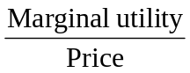 = 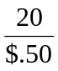 = 40 per dollar.

For oranges: = 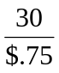= 40 per dollar.

Joe is spending $25 on apples and $30 on oranges, so he is spending a total of $55 on fruit. Therefore, Joe is maximizing his utility.

6. The substitution effect is likely to be much larger than the income effect. The drop in price of nearly 15 percent is fairly big and will make Fritos relatively cheaper in comparison to other similar snacks, inducing much substitution. The income effect will be tiny because most people don’t spend a large fraction of their incomes on Fritos, so their purchasing power will barely rise.

7. Mary is maximizing her utility if the (marginal utility)/price is the same for each good, and she is fully spending her budget allocated to corn chips and sodas. Since the marginal utility of both goods is 10, she is maximizing her utility only if the price of a bag of corn chips is the same as the price of a bottle of soda, and she is also spending the amount of her budget allocated to corn chips and sodas.

8. If pizza were an inferior good, the income effect would lead you to consume less pizza as its price falls. It is possible that a lower price would lead you to buy less if the income effect were larger than the substitution effect. In reality, the income effect is never larger than the substitution effect.

9. Yes, there is an income and substitution effect. As your wage rises, the “price” of leisure increases, so you will want to substitute work for leisure. On the other hand, the income effect of a higher wage will lead you to “buy” more leisure, because leisure is a normal good.

10. Network externalities arise when the usefulness of a product increases with the number of consumers who use it. This is very likely for fax machines, and perhaps for board games (the game is more interesting if all your friends are playing it, too), and both types of television sets, but not for dog food.

11. Network externalities can make it difficult for new products to enter certain markets. In the United States, 95 percent of personal computers run on the Windows operating system. Using an operating system other than Windows may make file sharing and other activities difficult. Because fewer people currently have personal computers in Asia, network externalities are less important than in the United States, and Linux may be more successful.

12. The endowment effect describes the tendency of people to be unwilling to sell something they already own for a price that is greater than the price they would be willing to pay to buy the good if they didn’t already own it. Your little brother is exhibiting the endowment effect. He is unwilling to sell the card for $20, even though he would not spend $20 to buy it.

13. Once a team has drafted a player, the team’s fans may be reluctant to see him traded to another team even if the trade would bring players of greater value. Knowing that their fans act according to the endowment effect, teams are often reluctant to draft a player if they intend to immediately trade him.

14. The restaurant will want to appear to be acting fairly to local customers because they are likely to return often. Businesses will sometimes set their prices below the equilibrium level, giving up some profits in the short run to keep their customers happy and increase their profits in the long run. On the other hand, the visitors to the Olympics are unlikely to return to the area, so the restaurant doesn’t lose their business if they think that it is behaving unfairly by raising its prices to the temporarily-high equilibrium level.

15. The text discusses two explanations: Rock concerts are a product that buyers consume together with other buyers. In those situations, the amount consumers wish to buy may be related to how much of the product other people are consuming. People like to consume, and to be seen consuming, a popular product. When a ticket to a concert is hard to get, the product is more popular. Raising the price of tickets until just enough are sold to fill the Garden might reduce U2’s popularity. Another explanation is that many people consider it fair for companies to raise their prices following an increase in costs, but unfair to raise prices following an increase in demand. Companies may sometimes not raise their prices even when the demand for their product is greater than the supply out of fear that in the long run they will end up losing customers who believe the price increases were unfair. These explanations share the same basic idea: sometimes giving up some profits in the short run keeps profits higher in the long run.

16. The firm may do this because customers think this is fair. It may also do this because a sell-out creates even more interest in the movie, bringing in more customers later in the week. The excess demanders from Spider-Man 3 may also decide to stay and watch their second-favorite movie, while planning to return to see Spider-Man 3 later.

17. Oldies 93 may or may not be doing its listeners a favor. They may be acting irrationally by ignoring the nonmonetary opportunity costs of getting the gas – like the opportunity costs of driving to the station or the likely cost of waiting in line to get the gas. Thus, Jack saved less than $10 because of the nonmonetary costs of buying the gasoline.

18. What you paid for your ticket is a sunk cost and, if you are rational, it should not affect your decision whether to attend.

19. The cost of the ticket is a sunk cost, which should be ignored by Neyer. Once he’s at the game, it would be rational to weigh the marginal cost of moving into the shade (a slightly worse view) versus the marginal benefits (greater physical comfort).

20. You will want to compare the marginal benefit of spending $4,000 to have the car repaired against the benefits you would receive from spending the $4,000 in other ways, such as by making a down payment on another car. The price you paid for your car is irrelevant to the decision of whether you should repair it.

21. By “long-run self,” they mean a person’s long-run objectives, such as succeeding in school or remaining thin. Going to the movies rather than studying, or eating donuts rather than sticking to a healthy diet, are two examples of pursuing immediate gratification.

22. The statement is probably correct. People often eat food like potato chips in the present because they tell themselves – unrealistically – that they intend to eat better in the future. If they were more realistic about their future actions, they would eat fewer potato chips today and the demand curve would shift to the left.

23. They seem to be behaving overly optimistically about their future behavior. At the time they sign up for the monthly fee, they seem to expect to attend more than 7 times per month.

24. The $3000 in recent refinancing fees is a sunk cost and should be ignored.

25. Coke uses celebrity endorsements because they increase demand among people who want to appear to be more fashionable or feel closer to the celebrity by using the product he or she endorses. Celebrity endorsements won’t be used for products where fashion isn’t a concern – for example, for intermediate inputs used to make other products, such as coal, cattle feed, photocopier paper or electricity – or products sold to people who don’t care much about popular fashions.

Answers to Appendix Problems and Applications

1a.
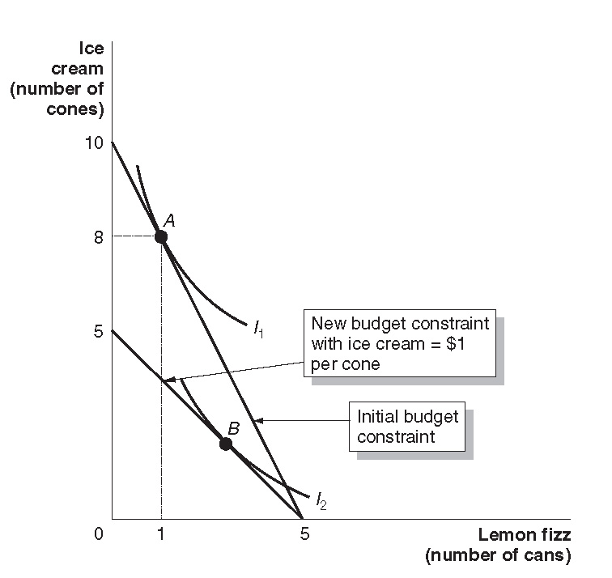
b. The indifference curve must be drawn so that it is tangent to the budget constraint at point A.
c. The budget constraint rotates inward (that is, counter-clockwise from the point where it intersects the lemon fizz axis at five lemon fizzes). The new optimum consumption point will be at a higher level of lemon fizz and a lower level of ice cream, such as point A, so draw an indifference curve that is tangent at such a point. Make sure that the indifference curves do not cross.

2a.
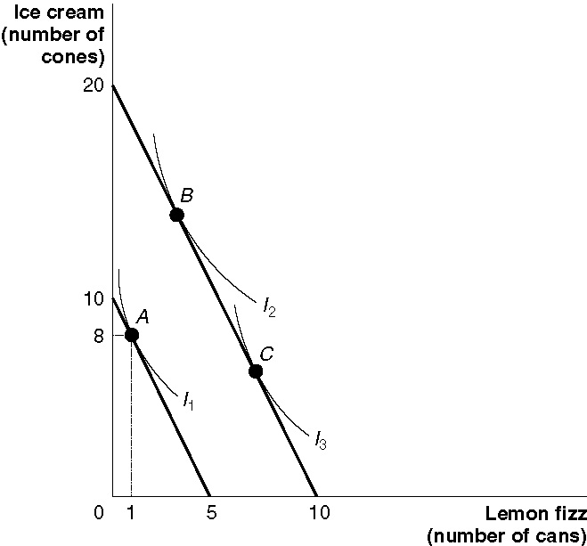

b. The income increase causes a parallel outward shift in the budget constraint. Because both goods are normal, higher income leads to greater consumption of both goods, shown by the move from the initial point of consumption (A) to a point like B.
c. If ice cream is inferior, consumption of it will fall as income rises, moving Jacob from point A to a point like C. (Indifference curves I₂ and I₃ may cross because they represent two different tastes.)

3a. Calvin’s indifference curves won’t be curved like the indifference curves in the appendix, they will be straight lines with a slope of negative one – showing that he is always willing to trade off one can of cola for one can of the other.
b. Because they taste exactly the same to him, he’ll buy whichever is cheaper.

4a. The prices of the goods can be found by dividing Nikki’s budget by the maximum amount that she can buy of each good. The price of blouses = $200/5 = $40. The price of skirts = $200/10 = $20.
b. Four blouses and two skirts cannot be the optimal point because the indifference curve going through this point isn’t tangent to Nikki’s budget constraint. She can reach higher indifference curves at points between the two intersections of her budget constraint and the indifference curve that is shown.

5. If both are choosing optimally, at their consumption point their marginal rate of substitution between milk and doughnuts will be the same. The marginal rate of substitution is the slope of the indifference curve. Each of them selects a point where his or her highest attainable indifference curve is tangent to his or her budget constraint, but these budget constraints must have the same slope because the prices facing them are identical. In the figure, Marilou has a higher income than Hunter. The slope of I_{H} at point H is the same as the slope of I_{M} at point M.

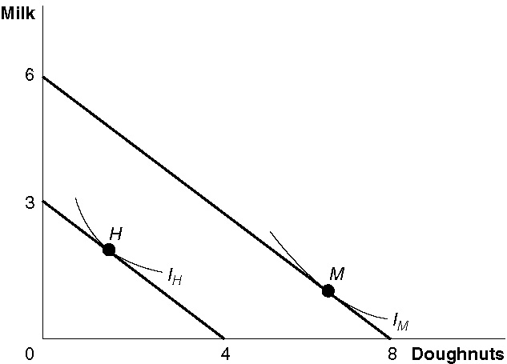

6. Because prices and incomes are unchanged for the typical consumer, the budget constraint doesn’t change. Instead, tastes change so the indifference curves change. The initial point of tangency was at a very low level of prune juice consumption, point A. But the new point of tangency is at a much higher level of prune juice consumption, point B.

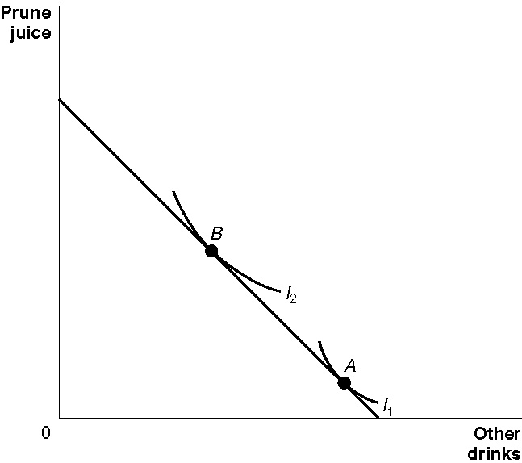

7. The new budget constraint goes through Dave’s initial point of consumption, point A. It cannot have the same slope as indifference curve I₁ at this point – since the indifference curve cannot be tangent to two budget constraints with different slopes. As the figure shows, Dave can now reach a higher indifference curve, I₂ at point B, so he is better off.

